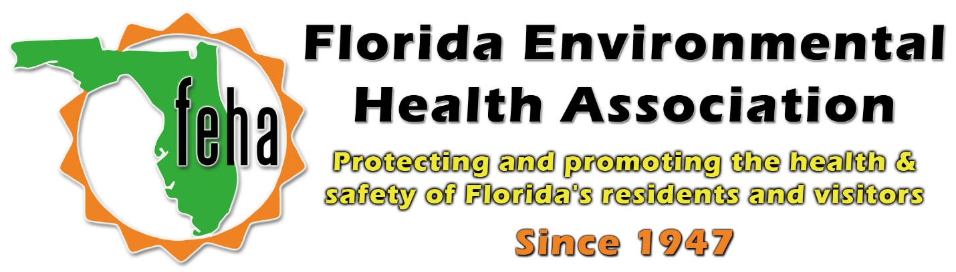

2021 Virtual FEHA Annual Education Meeting
October 13th-15th 2021
Session Title: Designing Risk Communication on Indoor Air Quality Risks after Flooding
Date: Wednesday October 13th
Time: 3:45pm-5pm
Speakers:
3:45pm: Keely Maxwell, PhD, MFS, Anthropologist,
Office of Research & Development;
4:10pm: Mary Reynolds, Physical Scientist,
Air & Radiation Division, Region 4 Office;
US Environmental Protection Agency (EPA)
5pm: End Session

Moderator:
Tim Wallace, RS, CEHP
Agenda:
Staff from EPA will provide updates on their Flooded Homes Website. The goal of this project was to increase awareness of risks after flooding occurs, including remediation, mold exposure, and other indoor air quality issues. This resource has been developed through effective risk communication that enables homeowners, renters and volunteers to take action after a flood. The website provides how-to videos, graphics and other information to meet their needs.
Dr. Keely Maxwell is an Anthropologist with the US EPA, Office of Research and Development. She develops & applies interdisciplinary research to environmental policy, natural resource management, & community resilience to disasters. She works as a General Anthropologist in the US EPA's Office of Research & Development, Center for Environmental Solutions & Emergency Response. There, she is developing an environmental social science research portfolio on community resilience, disasters, homeland security, and environmental cleanups. She served as chapter lead for the Built Environment, Urban Systems, and Cities chapter of the 4th National Climate Assessment and is the federal coordinating lead for the Human Social Systems chapter of the 5th National Climate Assessment. Keely completed her Ph.D. and M.F.S. at Yale University, and her B.A. at Williams College.
Mary Reynolds is a Physical Scientist and works at the US EPA, Air and Radiation Division in Region 4. She works in the Communities and Air Toxics Section as the Radon and Indoor Air Quality Coordinator. In this role, Mary focuses on outreach and education to raise awareness about radon and indoor air quality issues. She also serves as the Technical Project Officer for Radon and Indoor Air Quality Assistance Agreements. Mary works closely with state and local agencies to achieve EPA’s mission.

