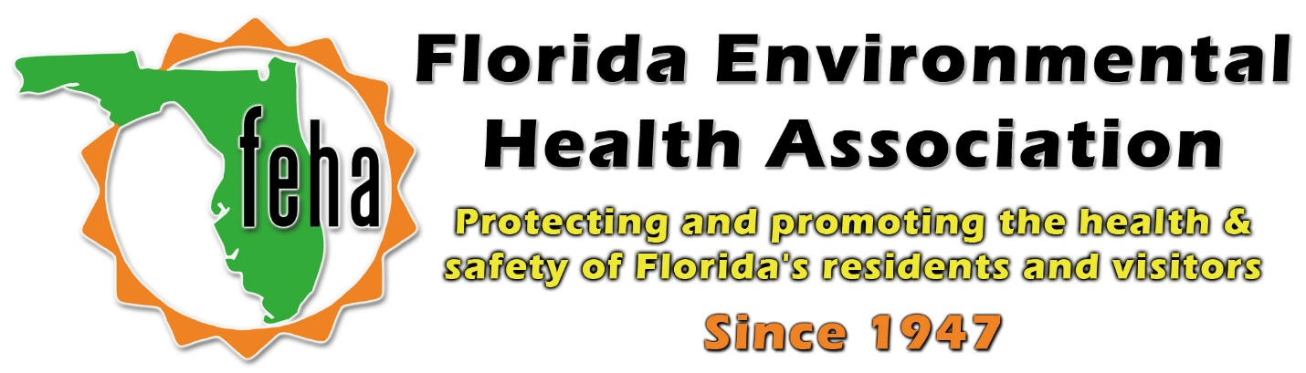

2021 Virtual FEHA Annual Education Meeting
October 13th-15th 2021
Session Title: Radiological Fundamentals and Preparedness in the Tampa Bay Region
Date: Friday October 15th
Time: 11-12:30pm

Speaker:

11am: Gary Frank, BS
Retired, RSO, Dept. of Health in Pinellas County
Co-chair, RDSTF Region 4 PRND
12:30pm: End

