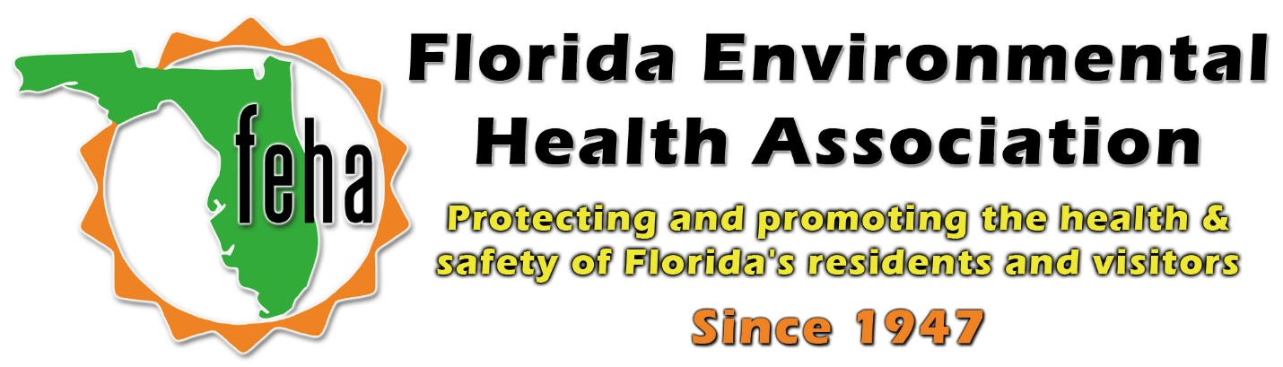

2021 Virtual FEHA AEM
October 13th-15th 2021
Session Title: US EPA – Updates on lead Poisoning Prevention, Pesticides/Disinfectants & Bedbugs
Date: Wednesday October 13th
Time: 1:30pm-3:30pm
Lead Poisoning Prevention: 1:30-2:15pm
Q&A: 2:15-2:30pm
Speaker: Emma Kaiser - U.S. Environmental Protection Agency Region 4, Florida State Contact
- Come learn about lead poisoning prevention and EPA’s lead-based paint regulations for renovators that help keep children safe from lead exposure! This presentation will go over the basics of lead, the hazards of lead exposure, and EPA’s Renovation, Repair, and Painting (RRP) rule and Abatement regulations.
Disinfectants 101 and Bed Bug Crash Course: 2:30-3:15pm
Q&A: 3:15-3:30pm
Speakers: Rose Yeley and Savannah Merritt – U.S. Environmental Protection Agency Region 4, FIFRA Outreach Contacts
- Did you know that disinfectants are EPA Registered pesticides? Join EPA to learn about how to properly use disinfectants. Then stick around for a crash course in Bed Bug management!

